**William Francis LORD**

14 January 1894- 18 May 1969

Born at Mansfield, but grew up in the Western District of Victoria (at Cobden/ Cobrico/ Pomborneit)

Moved to Melbourne in 1907, and enrolled at Melbourne High in 1910.

Frank became a Junior Teacher in March 1912 in Carnegie

Always known as Frank he enlisted as **Francis William LORD** on 10 August 1914

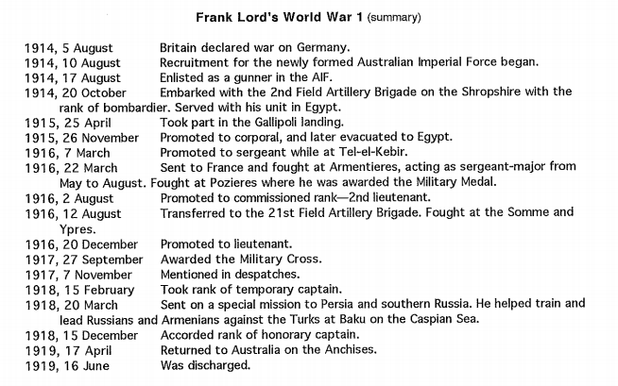

Following the war, Frank returned to teaching in primary schools

Errol St, Nth Melbourne (22/6/19 – 31/7/19)

Carnegie (1/8/19 – 8/9/19)

Glenhuntly (9/9/19 – 28/3/1923)

Paynesville (1/4/1923 - ?Sept 1925)

Merino (20/9/1925 – early 1927) and during this time, he matriculated (Jan 1924)

From 20 March 1927, he was an assistant at Melbourne Teachers’ College

Returning to school at Woorinen (8/1/1928 – 29/9/1928)

Then Lee St, Carlton (30/9/1928 into 1929)

He enrolled at Uni Melbourne in 1924, graduating BA Dip Ed on 23 Dec 1929.

After graduation - WWII

Frank took up an assistant’s role in humanities at Melbourne High, transferring from primary to secondary teaching.

In 1931, he started an MA but abandoned it due to the Depression

From 3 Jan 1931 he taught at Elwood.

Served as secretary of the Curriculum Committee 18/4/1932 into 1933 while teaching at Malvern East

Albert Park from January 1934 until mid 1937 at which time he again became an assistant at MTC where he was affiliated throughout WWII

WWII - retirement

In 1939, Captain Frank Lord undertook censorship duties, enlisting again in July 1940

He trained artillery units at Geelong and Puckapunyal, then sailed in May 1941 on ‘transport duty’

On return he trained more troops at Puckapunyal and Darly, sailing again to undertake legal work in courts of enquiry and Courts Martial in the Middle East, returning in December 1941, at which time he worked on beach defence at Ocean Grove.

Third sailing in 1942 for more legal work in Palestine, returning to Ocen Grove in March 1943. He was discharged on health grounds in June 1943.

Ballarat Teachers’ College reopened at Dana St in 1946 with Frank Lord as Principal.

He again enrolled for further study in 1949, but abandoned this after 1 term.

He became the founding Principal of Toorak Teachers’ College in 1951, retiring from there in 1958 and moving to Berwick.

Personal

Married (1920) Phoebe Myrtle Thorpe (1994-1989)

children Geoffrey (1921-1994) and Dorothy (1927-2020)

(1950) Anne Westmore

Many of these details are taken from [‘Frank Lord Teacher & Soldier’](https://victoriancollections.net.au/media/collectors/4f729f6797f83e0308601707/items/5d56363021ea670e0835e78b/item-media/5d56385921ea670e08385a32/original.pdf) by W. Wall, 1999. This essay is a short biography based on Wall’s MA thesis about Lord.