Barton, Edward Maurice Darval

“Pog”

ASC 1886-97

Obituary Bathurstian

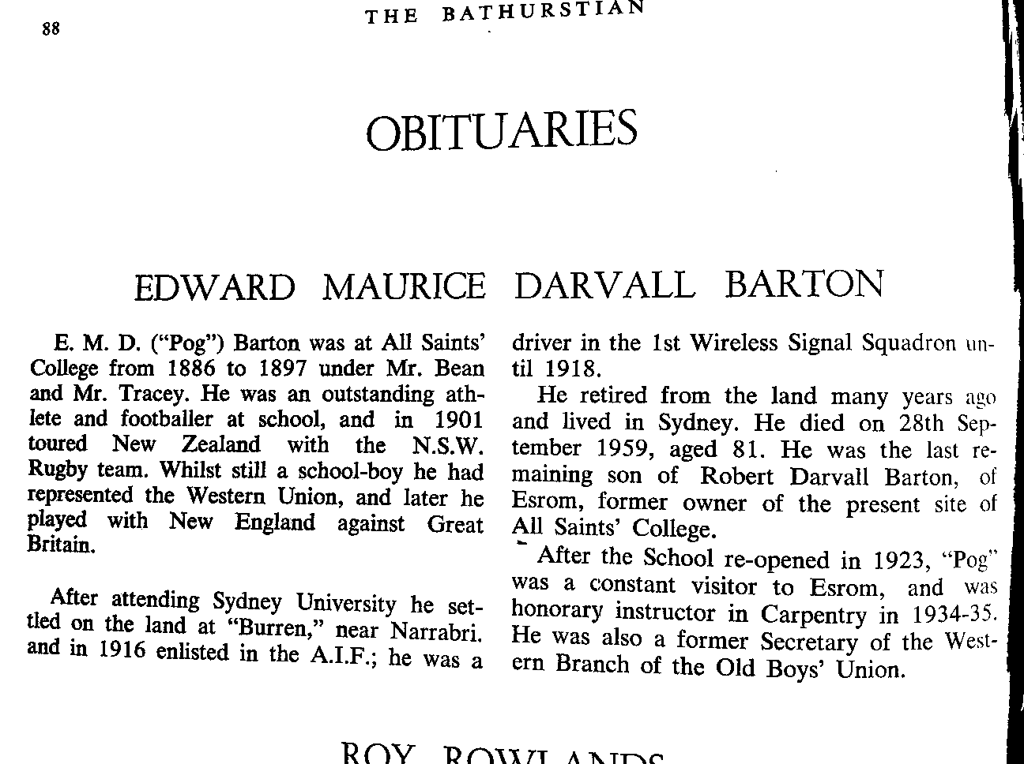

Bathurstian 1959 P.88

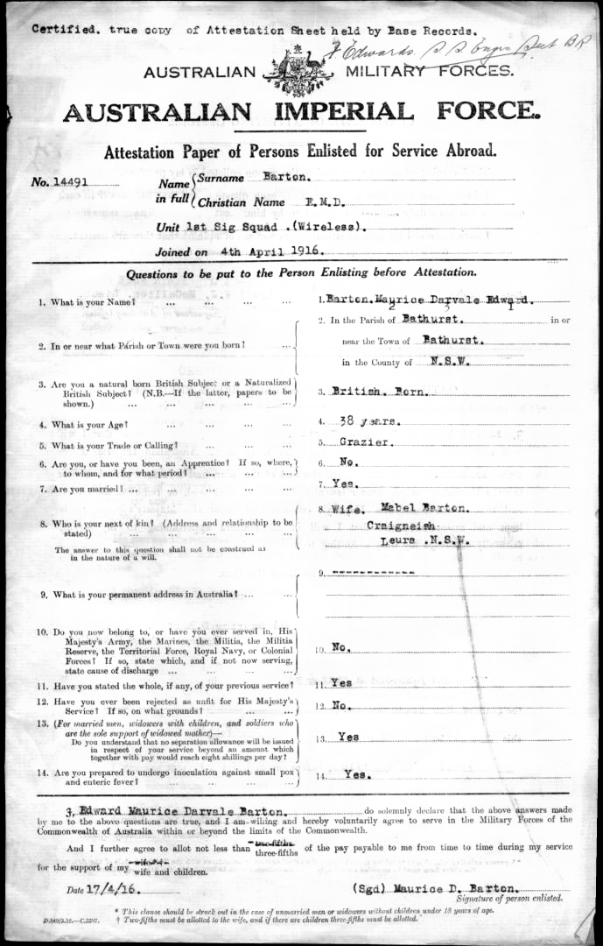

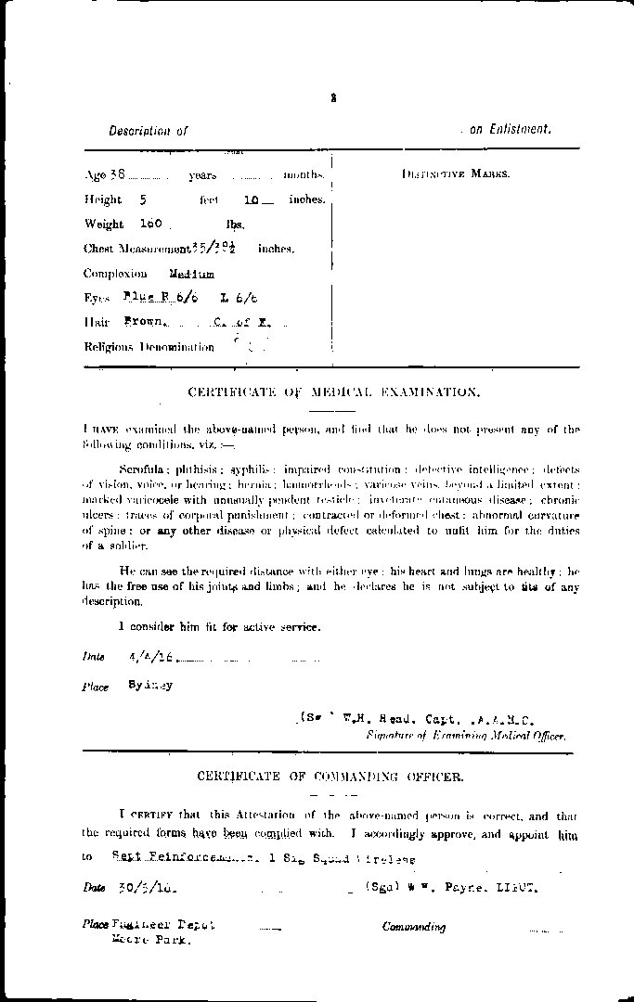

Extract from unit diary from period when Barton arrived.

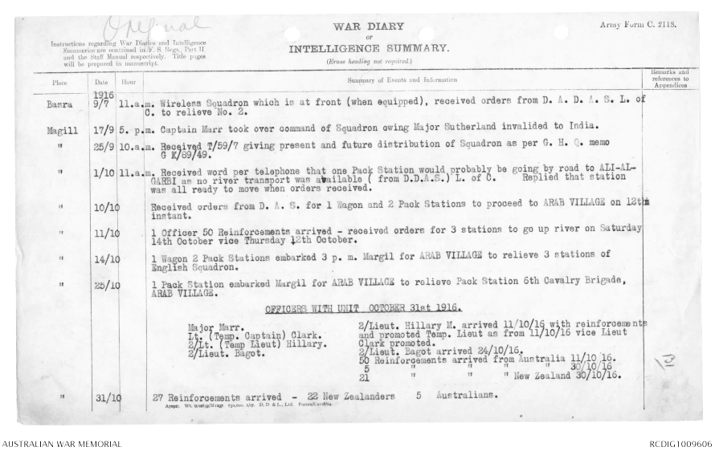

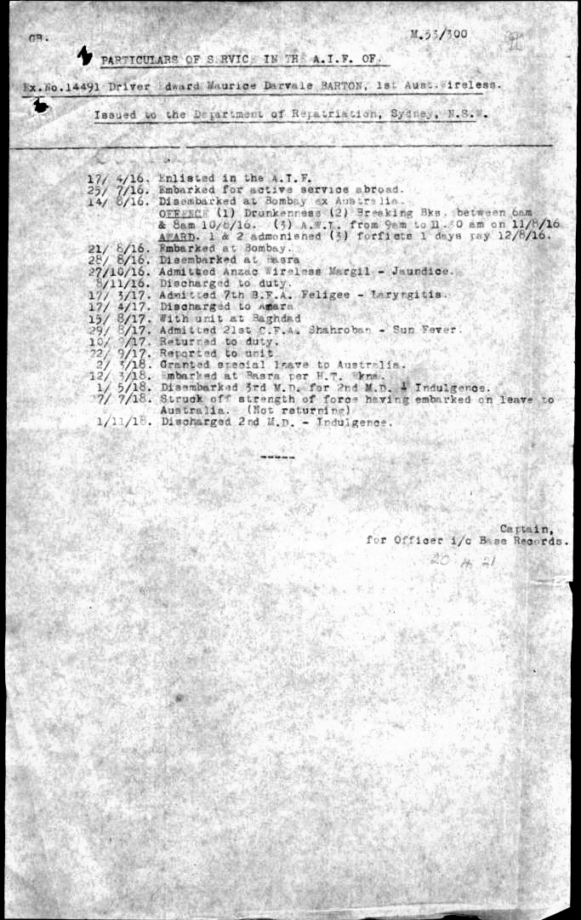
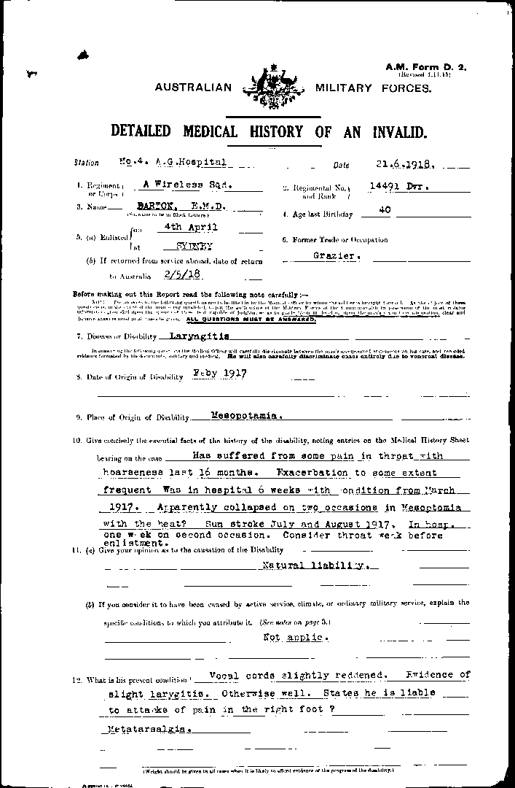
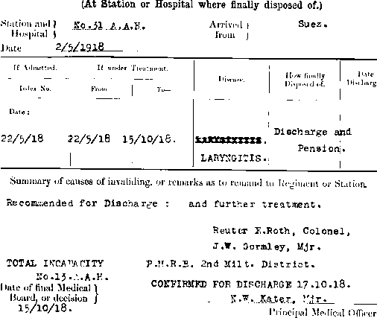

Note above signed off by old boy, Norman Kater.
Bathurstian 1959 P.88
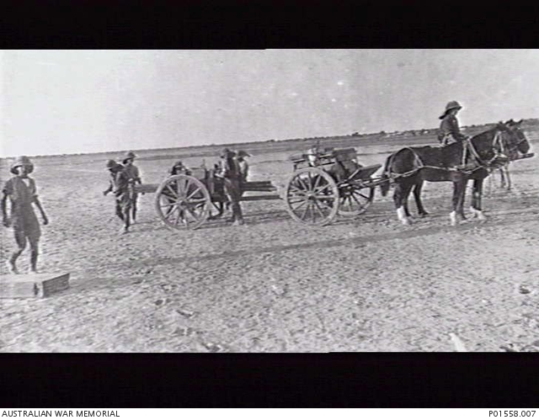

AWM
MESOPOTAMIA. C. 1917. HORSE DRAWN WAGONS WITH FIELD WIRELESS EQUIPMENT FOR THE 1ST AUSTRALIAN WIRELESS SIGNAL SQUADRON, MESOPOTAMIAN EXPEDITIONARY FORCE.
Driver, Australian Wireless Squadron, A.I.F., Mesopotamia. Enlisting in April, 1916, and sailing in July with 3rd reinforcements as driver, joined squadron 28th August and served as sergeant mechanic until return as driver, on recuperation leave, in May, 1918. Early education at All Saints'' College, Bathurst,
Sydney University, Book of Remembrance
B 20/4/78 Bathurst F Robert Darvall M Fanny Blanche Smith
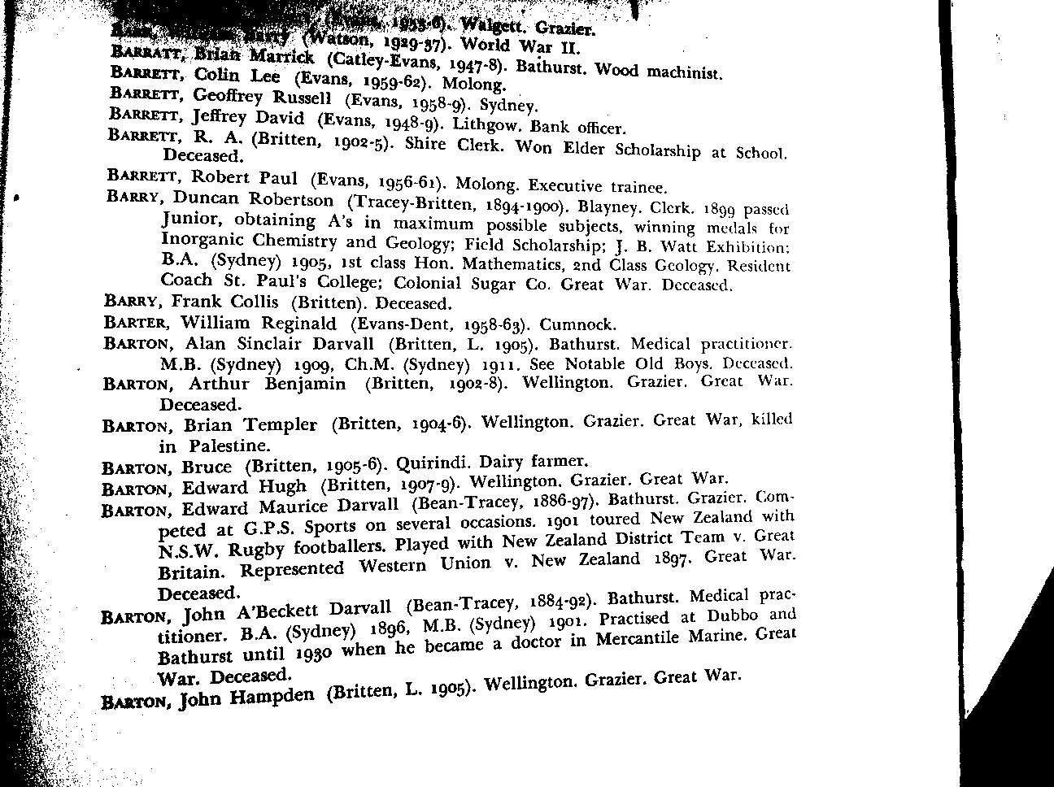
Extract from ASC Register
Died 1959

